**Procedure to Apply the PATCH file to**

**Talend TAC and Talend Studio**

Approval

| Signatures by each signatory indicate their acceptance that this document is complete and accurate to the best of his/her knowledge per responsibilities outlined in this document and as guided by approved methodologies and established procedures. | | |
| --- | --- | --- |
| Team Lead:  Artha Emp | **Subhransu** | **Date:** |
| Project Manager:  Artha Emp | **Pavan Valluri** | **Date:** |
| Talend Developer:  Artha Emp | **Omkar Patil** | **Date:** |

Step 1: - Download the Both PATCH Files from Talend Update Sites.

<https://talend-update.talend.com/nexus/>

username: - jorawarsingh

Password: - gae9ieSh3t-

Download the .zip file

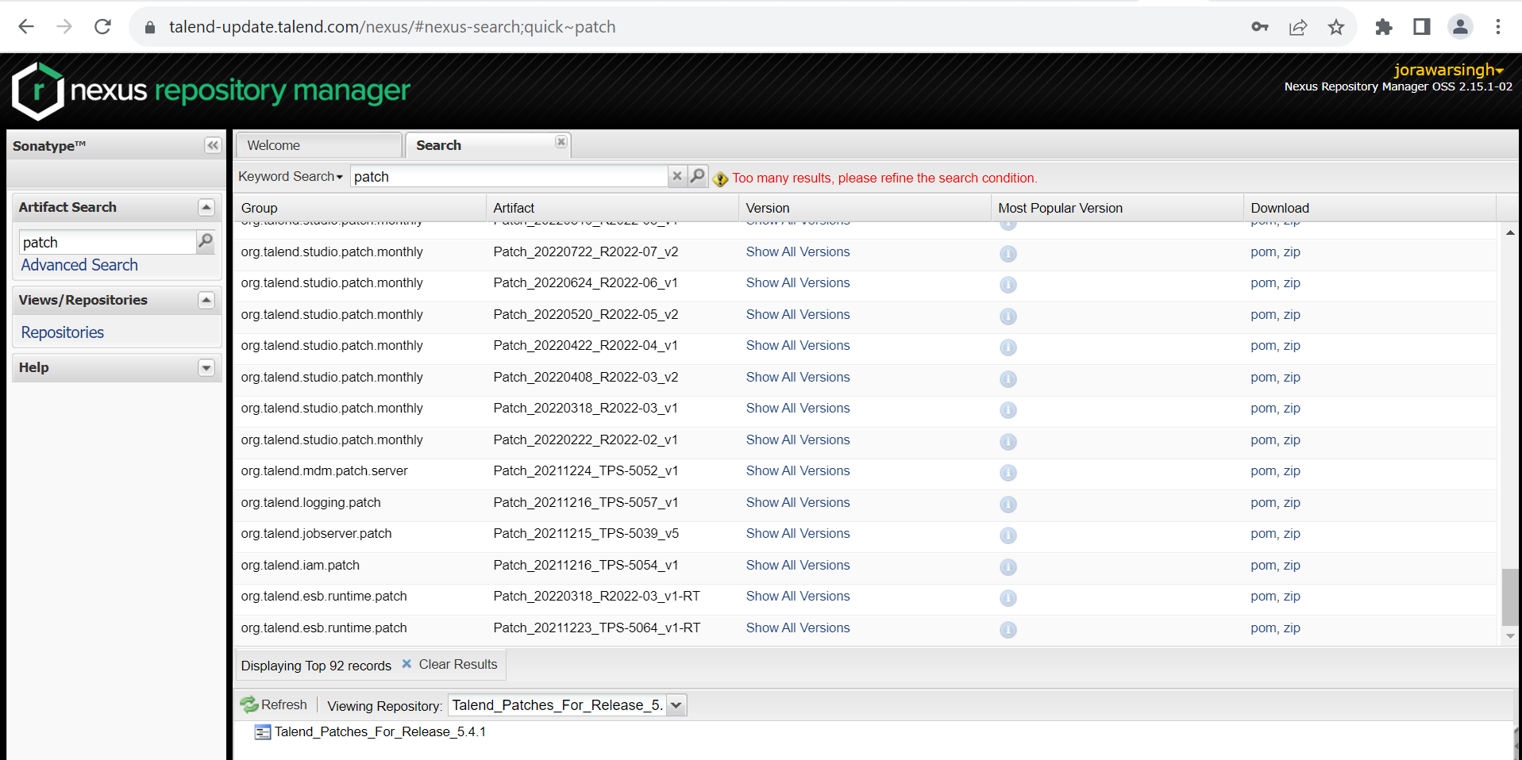

Step 2: - Open the TAC Installation Files

*Stop the TAC Services

systemctl stop talend-tac-8.0.1.service

cd /opt/Talend-8.0.1

mkdir TAC_Patches

mkdir TAC_Backup

Step 3: - Copy and Paste the Downloaded TAC Patch in the TAC_Patches directory

yum install unzip

unzip Patch_20230915_TPS-5495_v1-8.0.1.zip

unzip org.talend.administrator-8.0.1.war

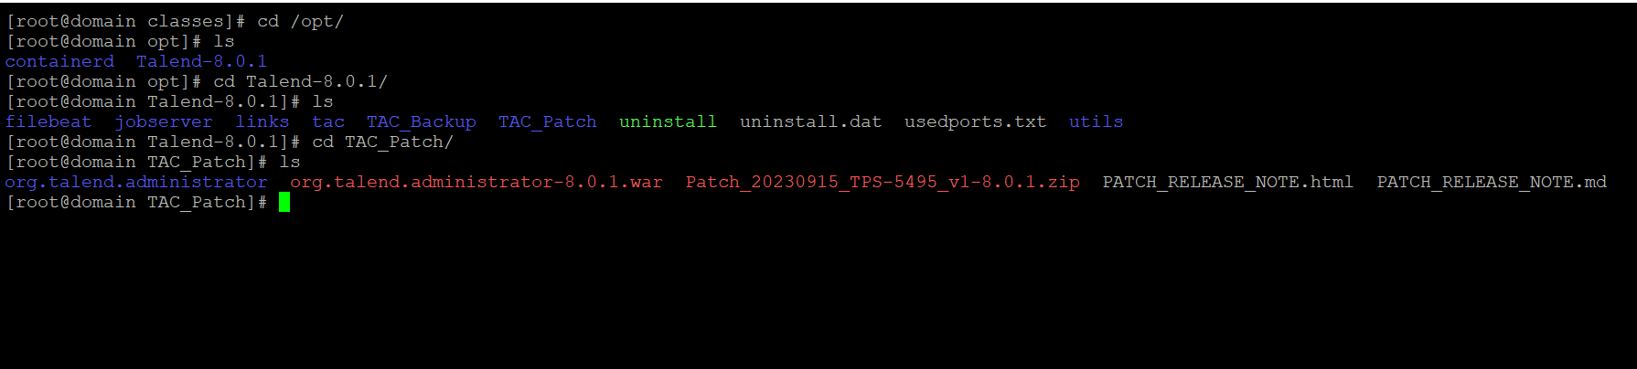

Step 4: - Take the Backup of org.talend.administrator in the TAC

cd /opt/Talend-8.0.1/tac/apache-tomcat/webapps/org.talend.administrator/

*copy org.talend.administrator folder to TAC_Backup directory

cp -R org.talend.administrator /opt/Talend-8.0.1/TAC_Backup/

*Delete the org.talend.administrator directory in TAC

rm –rf /opt/Talend-8.0.1/tac/apache-tomcat/webapps/org.talend.administrator/

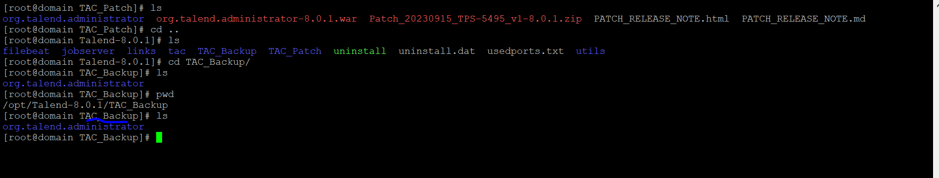

Step 5: - Copy the org.talend.administrator file from TAC_Patch directory to TAC webapps directory.

cp /opt/Talend-8.0.1/TAC_Patch/org.talend.administrator/ /opt/Talend-8.0.1/tac/apache-tomcat/webapps

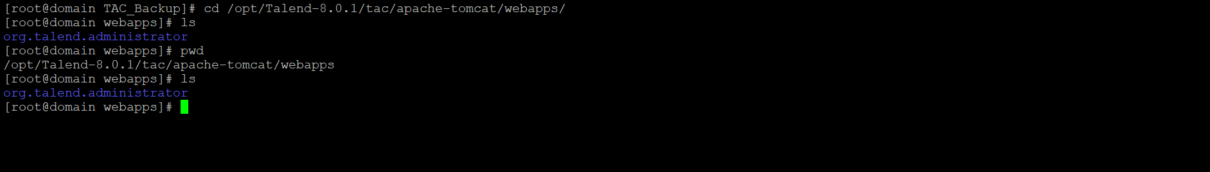

Step 6: - Copy and paste the configuration.properties and Quartz.properties files from TAC_Backup files to NEW TAC org.talend.administrator directory.

*copy the configuration.properties file

cp /opt/Talend-8.0.1/TAC_Backup/org.talend.administrator/WEB-INF/classes/configuration.properties /opt/Talend-8.0.1/tac/apache-tomcat/webapps/org.talend.administrator/WEB-INF/classes

*copy the quartz.properties file

cp /opt/Talend-8.0.1/TAC_Backup/org.talend.administrator/WEB-INF/classes/quartz.properties /opt/Talend-8.0.1/tac/apache-tomcat/webapps/org.talend.administrator/WEB-INF/classes/

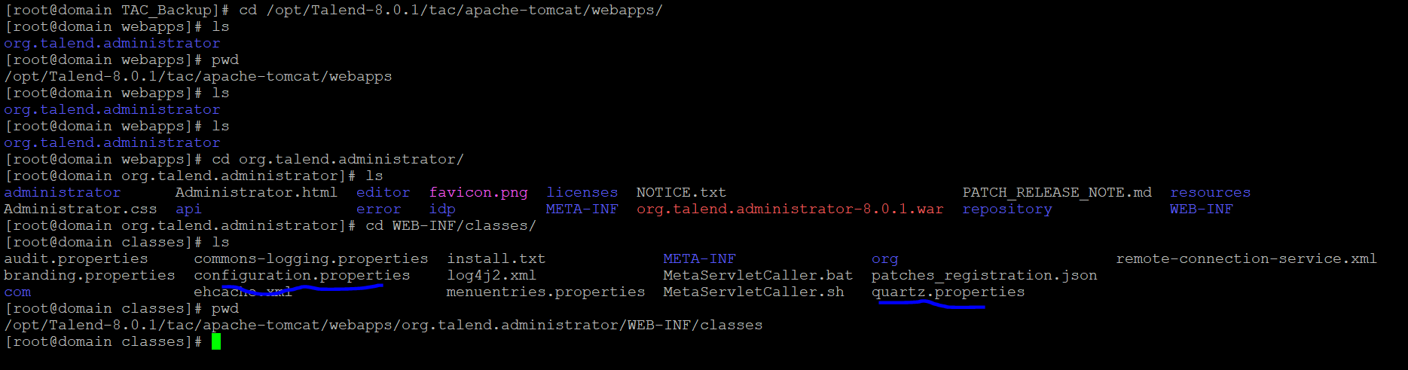

Step 7:- Restart the TAC

systemctl restart talend-tac-8.0.1.service

systemctl status talend-tac-8.0.1.service

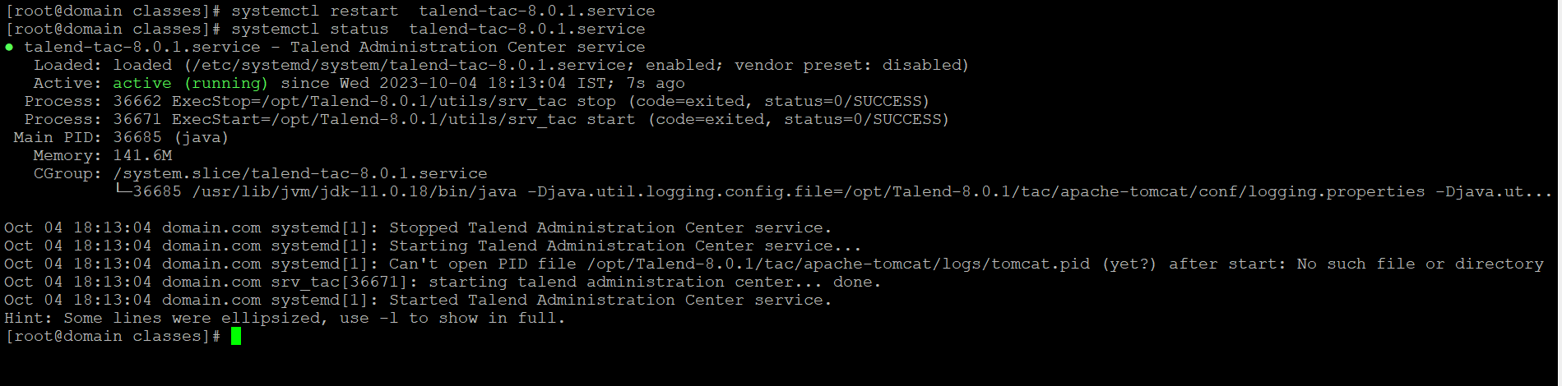

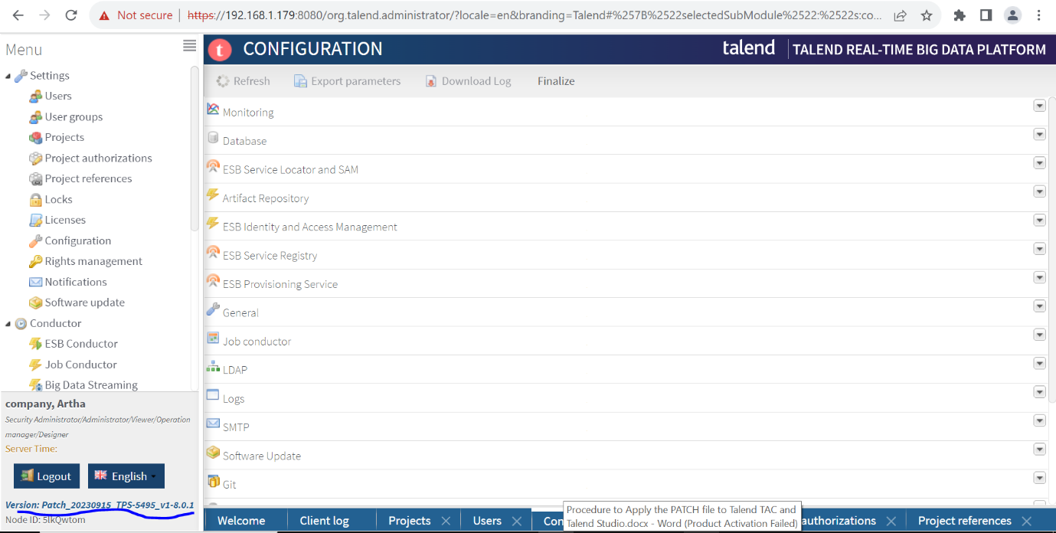

**Apply PATCH to Talend Studio**

Step 1:- Download the Latest Patch file

Step 2:- Create the Patch folder in Talend Installaion files.

Step 3:- Copy and paste the Patch file in Patch folder

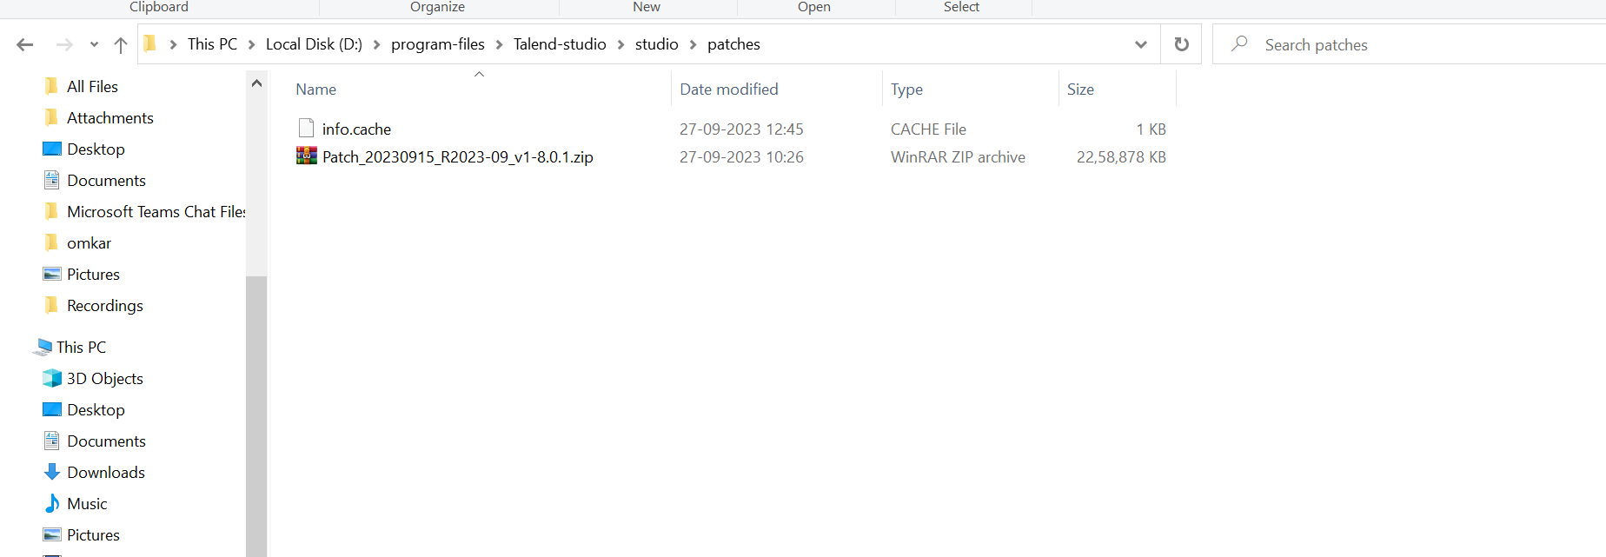

Step 4:- Restart the Talend Studio.

**OR**

Step 1:- open the Talend Studio.

Goto Windows -> preferences -> Talend updates

Configure the update configuration

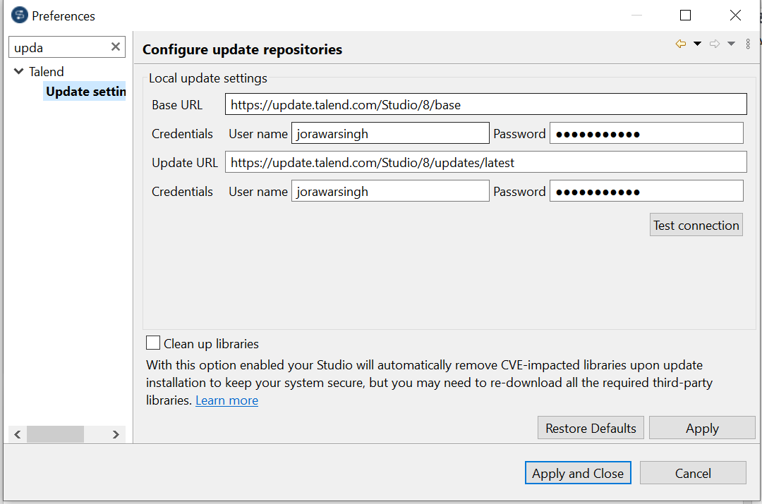

*Update Urls

<https://update.talend.com/Studio/8/updates/latest>

if patch in folder update url is

jar:file:/D:/program-files/Talend-studio/studio/patches/Patch_20230915_R2023-09_v1-8.0.1.zip!/

ministrator